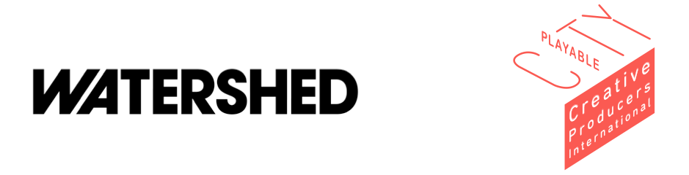

Creative Producers International – Information for Applicants.

Creative Producers International is a new worldwide talent development programme, designed to provide fifteen Creative Producers from across the globe with the tools they need to take leadership in the future of their cities. It will expand the ethos of our Playable City programme which has demonstrated the values of play and unexpected interaction in cities across five continents.

By the end of this programme our talented Creative Producers will become true change-makers. If you are selected, we will give you the ability to have a new kind of conversation with city leaders that keeps art at the heart of decision making. You will be able to transform how your community engages with their surroundings and deliver ground breaking projects at the intersection of creativity, technology and public space.

The result will be a diverse group of cities who influence, challenge and support each other, and have sustainable routes for sharing their knowledge and innovation all over the world.

Our seven producing partners will each nominate a Creative Producer of their choice to join the programme, and the remaining eight places will be filled through a worldwide open call for applicants.

The programme will run from the beginning of October 2017 to the end of December 2019.

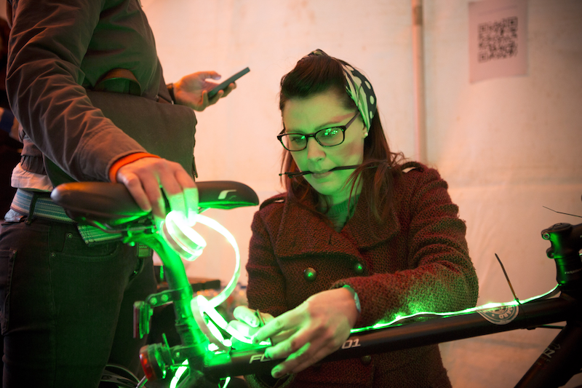

© Max McClure

What do we mean by Creative Producer?
The role of Creative Producer is often a difficult one to define.

For us, a Creative Producer is someone with the vision and practical skills to manage a successful project, as well as the commitment to collaborate generously with others, patiently nurture talent and display resilience and good judgement when faced with challenges.

“The reality of creating a network with these kinds of interventions is that when an idea pops in your head, you kind of know who to go to because you know that person is good at that thing and you can approach them.” - Tosin Oshinowo, Playable City Participant

Are you the kind of person we are looking for?

You might not think of yourself as a Producer at all. You might work in theatre, the music industry, or have a background in performance art or within the technology sector.

Ask yourself: Do you like to take risks? Are you passionate about transforming creative ideas into innovative new work that captivates audiences? Are you excited by the idea of collaborating with people from different backgrounds and disciplines? Would you like to transform the way your city values and engages with culture and technology?

We want to find people of all ages and with a range of skills and experience, but you should already feel confident in your ability to successfully curate artists and deliver ambitious projects in a live city context.

If any of these apply to you, and you want to inspire change in your community, we want to hear from you.

What we will expect of you

- A collaborative, open, rigorous and experimental approach
- Participation in a three-week residential lab in Bristol from the beginning of October 2017, including a Playable City Conference in Bristol on 19 October
- Attendance at a conference in Tokyo in October 2018
- Participation in two online digital labs
- Participation in an online community to share progress, practice and learning for the duration of the programme
- Using an ideas development grant, work in collaboration with Watershed to design a project and deliver it with your city
- Contribution to the documentation and evaluation of the programme
- Participation in peer to peer mentoring and monthly catch ups with the Watershed
Producer

What you will receive

- £2000 participation bursary each year for three years
- Travel, accommodation and per diems for the Bristol and Tokyo Events
- £5000 ideas development grant
- Opportunity to bid for a share of our feasibility fund
- High quality training, mentoring and support for three years and beyond
- Support with access needs if needed
- The opportunity to become part of a sustainable global network of creative thinkers, providing potential for collaboration and the exchange of knowledge and learning

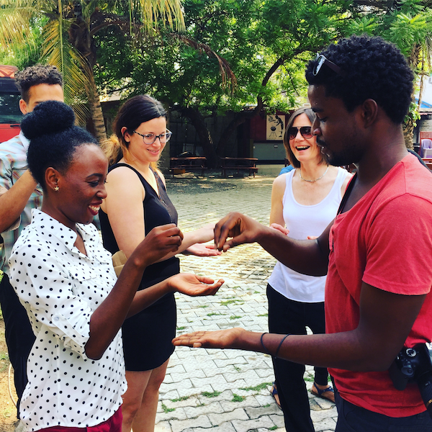

We will consider the following questions during the application process.

- Quality: What is your track record, taking into consideration the scale or ambition of your previous work?
- Fit: How does this opportunity fit with your current practice or ambition?
- Development: To what extent will the programme develop and enrich your practice in the medium to long term?
- Leadership: Do you have a credible commitment to creating change in your city?
- Impact: Do you demonstrate a commitment to sharing your learning with others?
- Approach: Do you advocate an open, rigorous, collaborative approach?

We are working with seven producing partners from cities across the UK and from Mexico, Nigeria and Japan. We of course welcome applications from these countries, but it is important for us to have a varied mixture of cities involved in the programme and this will be taken into consideration when making our final decision.

Please note:

If you have any questions or concerns about visas for attending our programme events, please contact Pete Vance (details below).

Due to the collaborative nature of the programme all of our Creative Producers must be able to communicate in either English or BSL with confidence (unfortunately we are unable to accommodate other forms of sign language).

We welcome applicants who are both freelance or in full or part time employment. Applicants in employment will need to provide a letter from their employer in support of their participation in the programme as part of the application process.

How to apply
If you are interested in applying to join the programme, please follow this link, which is also available on the Playable City website:

https://watershedbristol.typeform.com/to/KnYqLT

We realise that text-based forms do not necessarily suit everyone, so we are happy to accept submissions in the form of a video application. If you would like to discuss an alternative format please get in touch (details below).

- The closing date for all applications is Monday 5th June 2017 at 9am BST.

- We will confirm whether or not applicants have reached the interview stage on Thursday 8th June 2017.

- Interviews will take place via Skype on Wednesday 14th June 2017.

If you have any questions about the programme, the application process or any other queries, please contact Pete Vance at pete.v@watershed.co.uk or on +44 (0)117 370 8870.

You can learn more about Watershed on our website http://www.watershed.co.uk/, and visit www.playablecity.com to read all about our Playable City programme.

Creative Producers International is led by Watershed and supported by Arts Council England’s Ambition for Excellence Programme, British Council and University of West of England.

