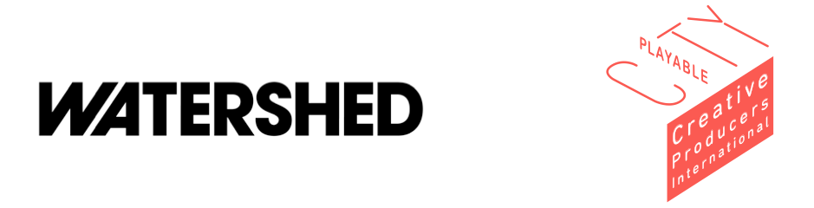

Creative Producers International. Programme Overview 2017 - 2019

Summary
Creative Producers International is a leadership development programme that will enhance the skills and vision of fifteen Creative Producers from around the world to become the city change-makers of the future.

Led by Watershed, and working with experienced UK and international producing partners, this unique scheme will develop a network of talent who can engage with citizens and their city leaders. Inspired locally, but engaged globally, they will produce creative projects that transform the conversation surrounding our future cities.

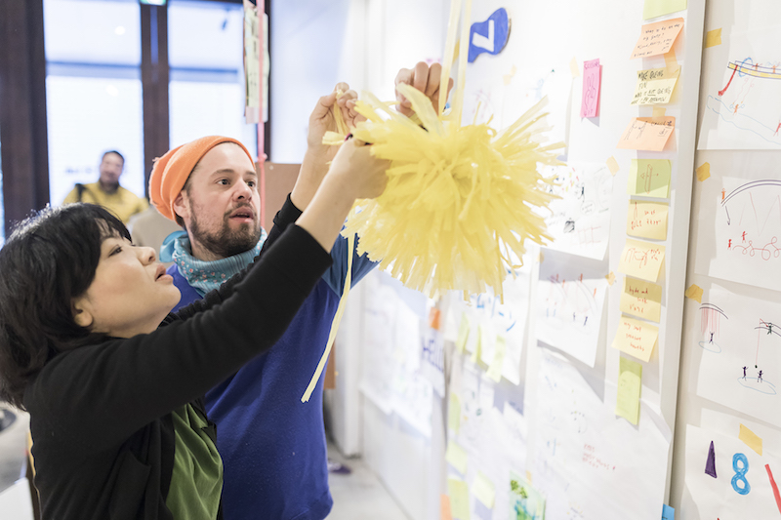
© British Council

Background
More than half of the world’s population now lives in cities, and how those cities grow, adapt and thrive is becoming the most vital issue of our age. However, this conversation is more focused on policy and technology than people and culture. Artists and cultural organisations have a unique opportunity to change this dialogue and reimagine the cities of the future.

The world needs cultural leaders who can converse with both city planners and their own local communities, to influence city development and ensure that citizens are engaged and public spaces remain open.

The programme will amplify and extend the reach of Watershed's Playable City, which puts people and play at the heart of future cities. This work creates a new kind of dialogue between citizens and their city, by transforming their surroundings into spaces of unexpected interaction. A combination of public space, creativity and imagination combine to inspire people with a vital message of change for the future. Playable City has been embraced by cities across five continents, in locations as diverse as Austin, Bristol, Lagos, Recife and Tokyo and beyond, and its impact continues to grow and inspire.

“We can create buildings with nice facilities but it is hard to find people who can both develop programmes and collaborate with artists, which is where the real differences are made.” – Manami Yuasa, British Council Japan

Creative Producers International will work with individuals from a wide range of backgrounds and disciplines, all able to benefit from their combined pool of knowledge and experience. They will have access to bespoke workshops with creative innovators at the very forefront of their industries, discovering the secrets of their vision and their process. We will provide our producers with the tools they need to engage with both the cultural and technology sectors, facilitate events that work across these disciplines and curate and produce incredible artists.

The Creative Producers will also have the opportunity to develop new long-lasting partnerships. They will build sustainable routes through which to showcase new work.

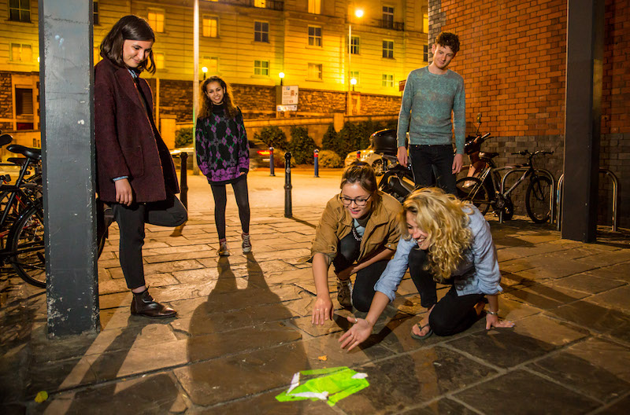
© Paul Blakemore

Creative Producers International brings together an international network of partners including Royal Shakespeare Company, Manchester International Festival, Somerset House, Unlimited, Lagos Urban Network (Nigeria), Rhizomatiks (Japan) and Laboratorio para la Ciudad (Mexico City).
Programme Elements
Creative Producers International has three connected, internationally engaged elements:

Creative Producers Development Programme
The programme will begin with a three-week residential lab at Watershed’s Pervasive Media Studio. Facilitated by Watershed and our Producing Partners, the lab will blend personal and project development, and cover different aspects of creative technology and public art production.

By the end of the month, the Creative Producers will be equipped with the knowledge and tools to design and deliver projects which lie at the intersection of creativity, technology and public space. They will become a network of city change-makers, able to validate their ambitions locally and deliver new work at an international scale.

Feasibility Fund
A feasibility fund will enable the Creative Producers to develop their skills in a live context through delivering prototype artist-led, creative technology enabled projects, designed and developed for different city contexts. We will support distinctive ideas, which make use of existing city infrastructure and creativity to make cities more liveable, hopeful and collaborative.

In year one, each Creative Producer will receive a £5,000 ideas development grant to explore and test a new piece of work for a city context. In years two and three, the Creative Producers will have the opportunity to apply for a share of an investment fund, and will work with together with the Watershed to unlock local support and match funding.

Events
A sequence of events will build a network, embed knowledge and showcase the work.
These will include:

Playable City Conferences
Two public conferences will be held as part of the programme, in Bristol and Tokyo. The Bristol conference will take place on 19 October 2017 at the heart of its Festival of the Future City, the world’s largest public debate about the future of cities. Our Tokyo conference will take place in October 2018.

These conferences will be in part designed and facilitated by the Creative Producers and will showcase ideas and share knowledge between artists, cultural organisations and cities working in this area.

Digital Labs
Networking and knowledge sharing opportunities for the cohort. Led by Fred Deakin, these Labs will pilot new ways of undertaking international knowledge sharing and exchange without always needing to invest in visits, thereby benefitting the environment and reducing costs.

Creative Producers International is led by Watershed and supported by Arts Council England’s Ambition for Excellence Programme, British Council and University of West of England.

