Position: Events General Assistant
Grade: 6
Responsible to: Events Manager
Purpose of Job
The post holder is a member of the team responsible for the delivery of conferences, events and festivals at Watershed.

Principal Responsibilities
- Set-up and de-rig events facilities, including moving furniture.
- Set-up and clear beverage and catering stations.
- Serve food and beverages to customers and undertake simple food preparation tasks.
- Deliver the highest standard of customer experience at all times.

Key Performance Indicators
- Excellent customer service with positive feedback from clients.
- Excellent communication within the team.
- Good time-keeping and a smart appearance.

Person Specification

Skills & Experience
- Customer focussed.
- Flexible, reliable and punctual.
- Good supportive team worker.
- Confident and calm under pressure.

Watershed Values
The Watershed brand is unique, trusted and respected and is driven by the following shared values which are clearly articulated. Ability to master and represent Watershed’s Vision and Values is therefore important.

Watershed is:

Inclusive | We are people led. We listen to and engage with the broadest range of people.
Open and Honest | We provide a culture and environment that is trusting, trusted and trustworthy.
Make Things Happen | We approach opportunity and challenge creatively, collaboratively and with a can do attitude.
Entrepreneurial | We are inventive, try new ideas, experiment, learn and share.
Celebratory | We celebrate culture, creativity and wonder.

Additional information:

- The post-holder will be required to undertake such other comparable duties as may be required.
- Watershed is open seven days a week, including Bank Holidays (Christmas Day and Boxing Day are the only exceptions). Watershed is a public building, which operates a diverse range of cultural and commercial activities. The post holder will need to be comfortable working in this environment.
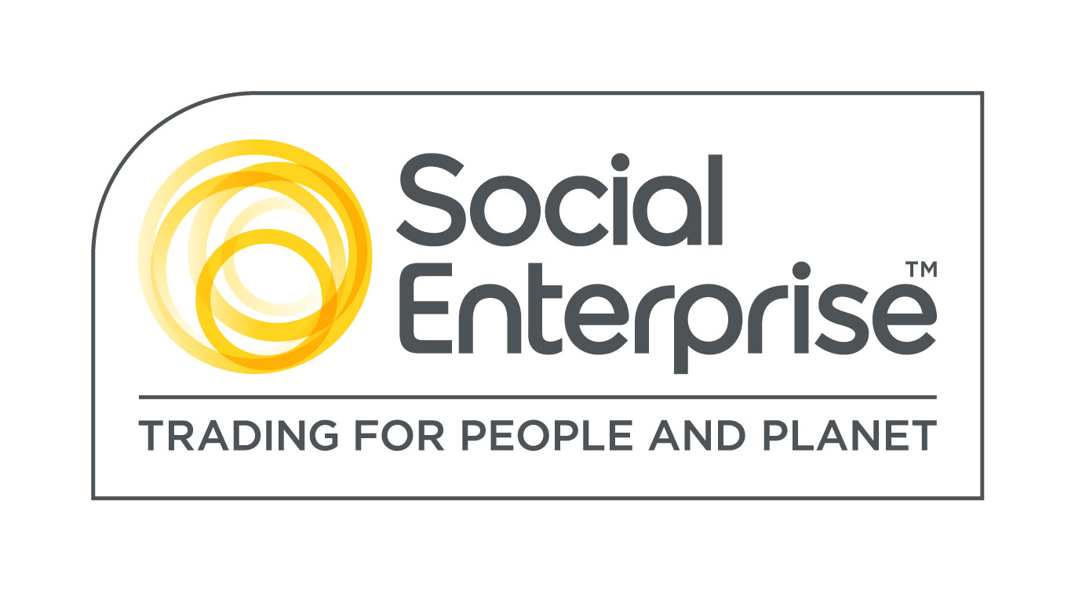
Watershed is a Social Enterprise Mark holder. Social Enterprises are businesses whose products and services create both social and environmental benefits.

