Thu 6 Dec 2018

Job title: Rife Content Creator
Hello!

Sammy and Bex here. We’re the Editors of Rife Magazine, an online platform hosted by Watershed that covers the stories that matter to young people. Everything we publish is created by under 24s, because we believe your voices should be part of the media landscape so it is relevant and representative.

Our roles as Editors are focused in two areas: Sammy is Rife Editor of Written Content. Sammy helps shape all the written stuff we publish, things like articles, opinion pieces and lists. Bex is Rife Editor of Video Content. Bex looks after the visual side of things, like videos and photos. You’ll be expected to create both written and visual content while you’re working here. We can support you with the skills, tools and advice you need to make anything we think will be a great fit for the website, and that we all think will resonate with other young people (our target audience is under 24s).

In return, you’ll leave Rife after six months with an impressive portfolio of online content to kickstart your creative career, a whole new set of transferable skills, a new perspective on the creative industries, bags of confidence and a network of contacts that will be invaluable as you head into the future.

We’re keen to work with people who have an interest in journalism. For us, this means getting your ideas about the world out there – whether that be reporting on something that’s going on in Bristol, talking about an opinion you have in an inclusive and engaging way, or recognising a trend you think other people should know about. You don’t need any specific academic qualifications or journalistic training to apply. We’re most interested in your creative work and your passion for getting stories out there.

We’d like to employ two content creators who are at the start of their creative careers, but have some proof of their creative work so far. If you have a blog, an Instagram account showcasing your work, or anything similar, we’d like to see it as part of your application. You don’t need to know exactly where your creative work is taking you yet – we can help you work that out.

As a Content Creator, you’ll be expected to learn to do lots of different things: writing in a thought-provoking way and engaging way; making snappy, eye-catching video content; running multiple social media accounts, and helping to deliver workshops and events for other young people are the main ones. You’ll be part of a buzzing office where there’s lots going on. You’ll be expected to manage your own time and work to deadlines. Don’t worry if you haven’t done these things before – we will be here to support you, but you must be willing to learn how to do them, and to take direction from us.

We also aim to be as inclusive as possible and work hard to accommodate all access requirements. We realise there are always things we can do better though, so if there are things you would like to discuss, we will definitely listen and tailor how we do stuff to support you as best we can.

Ready to apply?! The Job Description (below) includes more information about the role, what will be expected and the terms and conditions of employment. Please read this carefully and decide whether this is the job for you. If it is, we’ve included a few tips in the next bit to help you along the way.

Tips for making an application:
To submit the best application possible, we suggest you:

- Answer the questions (sounds obvs but do make sure you read them properly);
- Be concise (don’t tell us everything you’ve ever done, pick out the things that are most relevant to the job);
- Please DO NOT send us your CV (it won’t be considered - pop all relevant info on your application form);
- Don’t stress about the level of your academic qualifications or your past jobs (we’re most interested in your creative work, your ambitions and your passion for getting your ideas about the world out there);
- If you’re planning to send links or examples of work, choose good quality examples that are most relevant to the position;
- If you’ve written for us before, here’s an easy win tip – TELL US!
- Ask us questions if you need to (don’t be afraid to do this, there are no silly questions).

How to apply for the role of Rife Content Creator:
There are 3 things you need to do:

- Read the Job Description
- Fill in the online Application Form
- Fill in the online Equal Opportunities Monitoring Form

We want to understand more about who applies to work with us, so we can ensure we are doing everything we can to be as inclusive as possible. This is why we invite you to complete our equal opportunities monitoring form. The information you provide will help us better understand what we are achieving and where we need to work harder. The form is completely anonymous. It is kept separate from your application and will not be part of the shortlisting process. We would love it if you filled it in.

We most definitely encourage applications from people of all backgrounds, but we particularly encourage applications from BAME candidates, because they are under-represented within our staff team.

We will also work with shortlisted applicants to ensure that any access requirements are met during the interview process and do not factor in decision making.

Application Timeline:
- Deadline for applications: 10am Thursday 10 January 2019
- We will let you know if your application was successful by Friday 18 January 2019
- Interviews will take place on Tuesday 22 Jan 2019 at Watershed in Bristol

If you have access requirements and/or if you’d like to discuss the role before applying, please feel free to contact Sammy and Bex via email: editor@rifemagazine.co.uk

Thanks for your interest in the position,

Sammy and Bex
Rife Editors

“Rife prides itself in giving young people a voice. I feel that I’ve definitely been able to find my voice and direction through working here.” Tim Lo, Rife Content Creator 2018

Position: Content Creator, Rife Magazine
Contract: 6 months, 4 days a week
Salary: £12,948 per annum (£6,474 for 6 month contract)
Responsible to: Rife Editor (Written Content) / Rife Editor (Video Content)
Purpose of Job

Rife Magazine is an online platform covering the stories that matter to young people. Everything we publish is written by under 24s, because we believe your voices should be part of the media landscape so it is relevant and representative.

You will join us for six months in a paid role, as part of a cohort of two Rife Content Creators. You will make content for Rife Magazine – personal essays, opinion pieces, interviews, articles, videos and photos that will resonate with other young people (our target audience is under 24s). You will also help to stage events, deliver workshops and represent Rife at festivals, careers fairs and other relevant places. In return, you will be mentored by an experienced team of creatives who will help you produce an impressive portfolio of online content to kickstart your creative career. You will also gain a whole new set of transferable skills, a new perspective on the creative industries, and a network of contacts that will be invaluable as you head into the future.

What Exactly Will You Be Doing?

- Reporting on activities and stories in the city that are important to young people;
- Creating, scheduling and publishing written, image and video content for the website and social media channels;
- Curating online content by young content creators in Bristol;
- Taking an active role in Rife editorial planning meetings;
- Taking an active role in the development and production of Rife events;
- Being an advocate for Rife in peer mentoring sessions and at events;
- Advising on the development of Rife and attending Rife Steering Group meetings;
- Attending training and actively pursuing personal goals;
- Adopting safe working practices at all times, and conforming to all relevant Safeguarding, Data Protection and Health and Safety procedures (we will train you up on these things)

How Do We Measure Your Progress? What Indicates That Things Are Going Well?

- Rife Magazine is up-to-date and active with work produced by content creators and under 24’s from across the city;
- The content you create and publish is well timed, interesting and relevant to the target audience;
- The events you work on are relevant, enjoyable, encourage under 24’s in the city to meet and learn, and are well communicated and documented;
- You’re eager to learn, you develop new skills and knowledge, and actively participate in meetings, mentoring sessions and training;
- You become great at communicating and have productive working relationships with Watershed staff, young people and partners that we work with;
- Your confidence improves and so does your awareness of the career choices available to you;
- If we ask you for feedback or short reports on the things you have worked on, you supply these on time and ensure the info you provide is accurate.

Personal Specification - what are we looking for?
- An interest in storytelling, digital media and the things under 24s care about
- Good writing skills and an interest in journalism
- Understanding and interest in photography and video
- Good level of IT literacy (preferably on Mac)
- Confident user of social media
- Shows initiative and positive approach to problem solving
- Proven ability to work independently under direction and as part of a team

Watershed Values
The Watershed brand is unique, trusted and respected and is driven by the following shared values. The ability to understand and represent Watershed’s vision for Rife and our Values is important.

Watershed is:
Inclusive | We are people led. We listen to and engage with the broadest range of people.
Open and Honest | We provide a culture and environment that is trusting, trusted and trustworthy.
Make Things Happen | We approach opportunity and challenge creatively, collaboratively and with a can do attitude.
Entrepreneurial | We are inventive, try new ideas, experiment, learn and share.
Celebratory | We celebrate culture, creativity and wonder.

Additional information:

- The successful applicant will be required to undertake an enhanced Disclosure and Barring Service (DBS) check, previously known as a CRB check.
- The post-holder is expected to wear clothing appropriate to their post.
- The post-holder will be required to undertake such other comparable duties as may be required by the Head of Department.
- Watershed is open seven days a week, including Bank Holidays (Christmas Day and Boxing Day are the only exceptions). Watershed is a public building, which operates a diverse range of cultural and commercial activities. The post holder will need to be comfortable working in this environment.

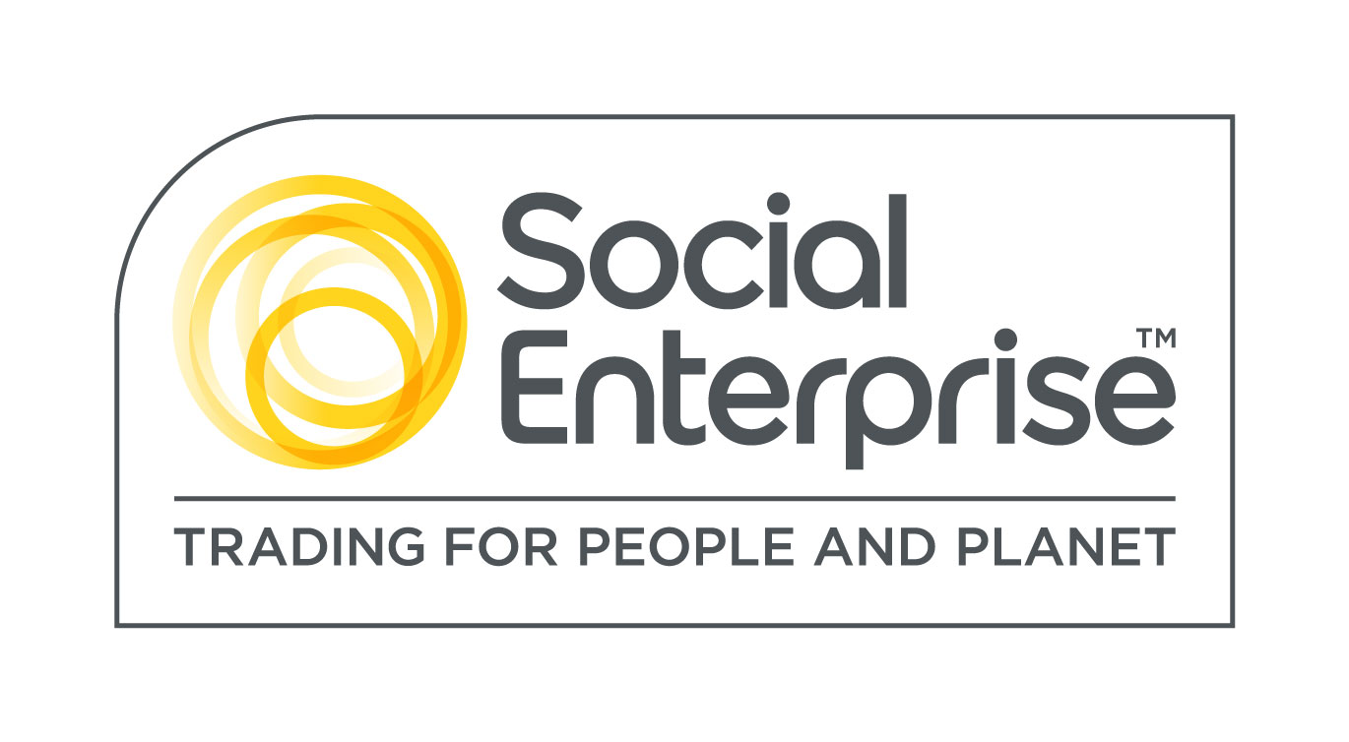
Watershed is a Social Enterprise Mark holder. Social Enterprises are businesses whose products and services create both social and environmental benefits.

