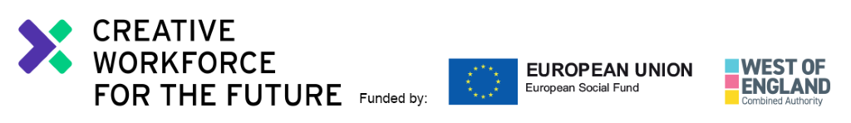
28th November 2019
Opportunity: Trainee Content Creator, Rife Magazine
Hello!
Sammy and Bex here. We’re the Editors of Rife Magazine, an online platform hosted by Watershed that covers the stories that matter to young people. Everything we publish is created by young people because we believe your voices should be part of the media landscape so it is relevant and representative.

Our roles as Editors are focussed in two areas: Sammy is Rife Editor of Written Content. Sammy helps shape all the written stuff we publish, things like articles, opinion pieces and lists. Bex is Rife Editor of Video Content. Bex looks after the visual side of things, like videos and photos. You’ll learn how to create both written and visual content as part of your trainee role. We can support you with the skills, tools and advice you need to make anything we think will be a great fit for the website, and that we all think will resonate with other young people.

In return, you’ll leave Rife after 24 weeks with a portfolio of online content to kickstart your creative career, a whole new set of transferable skills, a new perspective on the creative industries, bags of confidence and a network of contacts that will be invaluable as you head off to your industry placements and into the future.

We’re keen to work with people who have an interest in journalism. For us, this means getting your ideas about the world out there – whether that be reporting on something that’s going on in Bristol, talking about an opinion you have in an inclusive and engaging way, or recognising a trend you think other people should know about. As this is a training role, you don’t need any specific academic qualifications or journalistic training to apply. We’re most interested in your creative work and your passion for getting stories out there.

We’d like to employ two Trainee Content Creators who are at the start of their creative careers, but have some proof of their creative work so far. If you have a blog, an Instagram account showcasing your work, or anything similar, we’d like to see it as part of your application. You don’t need to know exactly where your creative work is taking you yet – we can help you work that out.

As a Trainee Content Creator, you will learn to do lots of different things: writing in a thought-provoking and engaging way; making snappy, eye-catching video content; and helping to deliver workshops and events for other young people are the main ones. You’ll be part of a buzzing office where there’s lots going on. You’ll be expected to manage your own time and work to deadlines. Don’t worry if you haven’t done these things before – we will be here to support you, but you must be willing to learn how to do them, and to take direction from us.

We also aim to be as inclusive as possible and work hard to accommodate all access requirements. We realise there are always things we can do better though, so if there are things you would like to discuss, we will definitely listen and tailor how we do stuff to support you as best we can.
Ready to apply?! The attached details include more information about the role, what will be expected and the terms and conditions. Please read this carefully and decide whether this is the opportunity for you. If it is, we’ve included a few tips in the next bit to help you along the way.

Tips for making an application:
To submit the best application possible, we suggest you:
- Answer the questions (sounds obvious but do make sure you read them properly);
- Be concise (don’t tell us everything you’ve ever done, pick out the things that are most relevant to the role);
- Please DO NOT send us your CV (it won’t be considered - pop all relevant info on your application form);
- Don’t stress about the level of your academic qualifications or your past jobs (we’re most interested in your creative work, your ambitions and your passion for getting your ideas about the world out there);
- If you’re planning to send links or examples of work, choose good quality examples that are most relevant to the role;
- If you’ve written for Rife before, here’s an easy win tip – TELL US!
- Ask us questions if you need to (don’t be afraid to do this, there are no silly questions).

How to apply for the role of Trainee Content Creator:
These are the things you need to do:
- Read the Role Description
- Fill in the online Application Form
- Fill in the online Equal Opportunities Form

This time round we’re part of something bigger - Creative Workforce for the Future. This means we’re part of a positive action programme, and for the pilot year we’ll only be accepting applications from:
- 18-30 year olds
- Who are either: of black or other minority ethnic origin, or someone with a disadvantaged socio-economic background,* or both.
* you can tell if you fit this criteria by thinking about the type of school you attended at age 11-16, whether you got free school meals, if you are or were a carer, if your parents went to university, what your parents did when you were 14, and what your housing situation was like when you were aged 11–16.

Everyone that applies to the Creative Workforce for the Future programme – regardless of whether you get a placement - will be invited to join the Talent Network. This will connect you with a community of creative talent, give you access to industry led masterclasses, networking events, mentoring and sign-post you to jobs and opportunities.

The closing date for all applicants is: 9am Monday 16th December 2019
Interviews will take place on: Tuesday 14th January 2020
Placement starts: Monday 27th January 2020
If you have access requirements and/or if you’d like to discuss the role before applying, please feel free to contact Sammy and Bex via email: editor@rifemagazine.co.uk
Thanks for your interest in the position!

Sammy and Bex, Rife Editors

“Rife is not lying when it says it cares about the voices of young people. Never have I felt as heard as I have in Rife, it provided me a platform. I don’t feel like I have to defend who I am anymore.”
Asmaa Jama Rife Content Creator 2019

Position: Trainee Content Creator, Rife Magazine (Part-time 32 hours per week)
Responsible to: Rife Editor (Written Content) / Rife Editor (Video Content)
Contract: 48 weeks (24 weeks as a Rife Content Creator plus 24 weeks in industry placements)
The role

Rife Magazine is an online platform covering the stories that matter to young people. Everything we publish is written by young people, because we believe your voices should be part of the media landscape so it is relevant and representative.

You will join us for 24 weeks in a paid trainee role, as part of a cohort of two Rife Content Creators and a Social Media Assistant. You will learn how to make content for Rife Magazine – personal essays, opinion pieces, interviews, articles, videos and photos that will resonate with other young people. You will also learn how to stage events, deliver workshops and represent Rife at festivals, careers fairs and other relevant places. You will be supported by the Rife Editors who will help you to produce an impressive portfolio of online content to kickstart your creative career and have a mentor who will support you to achieve your goals both whilst you are a Content Creator at Rife and on your industry placements.

This training role is part of positive action programme that is only open to candidates from a Black, Asian, Minority Ethnic or lower socio-economic background as these groups are currently not widely included within the creative and cultural sector.

This training role is part of Creative Workforce for the Future, which is a partnership between UWE Bristol, Watershed and five other cultural hubs – The Guild (Coworking Bath), Knowle West Media Centre, Spike Island, Creative Youth Network: The Station and Bristol City Council. The scheme aims to develop both industry employment practices to embrace inclusion and diversity as an asset, and nurture young talent - from certain groups who are currently not included - to gain the experience required to sustain a creative career. The scheme is funded by the West of England Combined Authority (WECA) and the European Social Fund (ESF).

You will also gain a whole new set of transferable skills, a new perspective on the creative industries, and a network of contacts that will be invaluable as you progress onto your industry placements and in your ongoing career.

What Exactly Will You Be Learning?

- Reporting on activities and stories in the city that are important to young people;
- Creating, scheduling and publishing written, image and video content for the website and social media channels;
- Curating online content by young content creators in Bristol;
- Taking an active role in Rife editorial planning meetings;
- Taking an active role in the development and production of Rife events;
- Being an advocate for Rife in peer mentoring sessions and at events;
- Advising on the development of Rife and attending Rife Steering Group meetings;
- Taking part in Creative Workforce for the Future Talent Network training and events
- Playing an active role in the Creative Workforce for the Future Talent Network
- Creating content that brings the stories of Creative Workforce for the Future to the Rife audience
- Attending training and actively pursuing personal goals;
- Adopting safe working practices at all times, and conforming to all relevant Safeguarding, Data Protection and Health and Safety procedures (we will train you up on these things)

How Do We Measure Your Progress? What Indicates That Things Are Going Well?

- Rife Magazine is up-to-date and active with work produced by Content Creators and young people from across the city;
- The content you create and publish is well timed, interesting and relevant to the target audience;
- The events you work on are relevant, enjoyable, encourage young people in the city to meet and learn, and are well communicated and documented;
- You’re eager to learn, you develop new skills and knowledge, and actively participate in the Creative Workforce for the Future Talent Network, meetings, mentoring sessions and training;
- You become great at communicating and have productive working relationships with your peers in the Talent Network, Watershed staff, young people and partners that we work with;
- Your confidence improves and so does your awareness of the career choices available to you;
- If we ask you for feedback or short reports on the things you have worked on, you supply these on time and ensure the information you provide is accurate.

Personal Specification - what are we looking for?
- An interest in storytelling, digital media and the things young people care about
- Good writing skills and an interest in journalism
- Understanding and interest in photography and video
- Good level of IT literacy (preferably on Mac)
- Confident user of social media
- Shows initiative and positive approach to problem solving
- Proven ability to work independently under direction and as part of a team

Watershed Values
The Watershed brand is unique, trusted and respected and is driven by the following shared values. The ability to understand and represent Watershed’s vision for Rife and our Values is important.

Watershed is:

Inclusive | We are people led. We listen to and engage with the broadest range of people.
Open and Honest | We provide a culture and environment that is trusting, trusted and trustworthy.
Make Things Happen | We approach opportunity and challenge creatively, collaboratively and with a can do attitude.
Entrepreneurial | We are inventive, try new ideas, experiment, learn and share.
Celebratory | We celebrate culture, creativity and wonder.

Additional information:

- The successful applicant may be required to undertake an enhanced Disclosure and Barring Service (DBS) check, previously known as a CRB check.
- The post-holder is expected to wear clothing appropriate to their post.
- Watershed is open seven days a week, including Bank Holidays (Christmas Day and Boxing Day are the only exceptions). Watershed is a public building, which operates a diverse range of cultural and commercial activities. The post holder will need to be comfortable working in this environment.

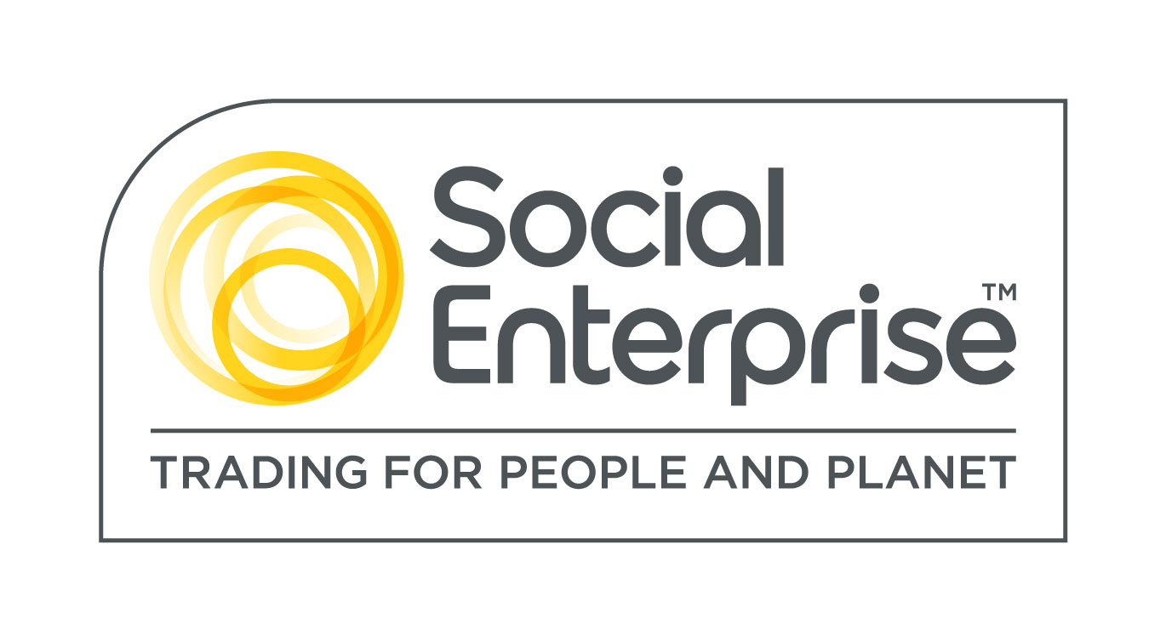
Watershed is a Social Enterprise Mark holder. Social Enterprises are businesses whose products and services create both social and environmental benefits.

Creative Workforce for the Future is Funded by the West of England Combined Authority (WECA) and the European Social Fund (ESF).

