28th November 2019

Opportunity: Trainee Social Media Assistant, Rife Magazine
Hello!

Sammy and Bex here. We’re the Editors of Rife Magazine, an online platform hosted by Watershed that covers the stories that matter to young people. Everything we publish is created by young people, because we believe your voices should be part of the media landscape so it is relevant and representative.

Our roles as Editors are focussed in two areas: Sammy is Rife Editor of Written Content. Sammy helps shape all the written stuff we publish, things like articles, opinion pieces and lists. Bex is Rife Editor of Video Content. Bex looks after the visual side of things, like videos and photos. You’ll be working with both of us to develop social media strategies and content.

We hope you will leave Rife after 24 weeks with more experience, a new set of transferable skills, a new perspective on the creative industries, more confidence and a network of contacts that will be invaluable as you head into the future.

We’re keen to work with people who have an interest in journalism. For us, this means getting young people’s ideas about the world out there – whether that be reporting on something that’s going on in Bristol, talking about an opinion you have in an inclusive and engaging way, or recognising a trend you think other people should know about. As this is a training role, you don’t need any specific academic qualifications or journalistic training to apply. We’re most interested in your creative work and your passion for getting stories out there through social media.

As Trainee Social Media Assistant, you will learn to do lots of different things: writing snappy tweets; making eye-catching Instagram content; running multiple social media accounts, plus helping to cover events. You’ll be part of a buzzing office where there’s lots going on. You’ll be expected to manage your own time and work to deadlines. Don’t worry if you haven’t done these things before – we will be here to support you, but you must be willing to learn how to do them, and to take direction from us.

This training role is supported by Rough Assembly and Creative Access. Through this role you will have the chance to take part in Creative Access Entry Support Programme of masterclasses, events and networking.

We also aim to be as inclusive as possible and work hard to accommodate all access requirements. We realise there are always things we can do better though, so if there are things you would like to discuss, we will definitely listen and tailor how we do stuff to support you as best we can.

Ready to apply?! The attached details include more information about the role, what to expect and the terms and conditions. Please read this carefully and decide whether this is the opportunity for you. If it is, we’ve included a few tips in the next bit to help you along the way.

Tips for making an application:
To submit the best application possible, we suggest you:

- Answer the questions (sounds obvious but do make sure you read them properly);
- Be concise (don’t tell us everything you’ve ever done, pick out the things that are most relevant to the job);
- Please DO NOT send us your CV (it won’t be considered - pop all relevant info on your application form);
- Don’t stress about the level of your academic qualifications or your past jobs (we’re most interested in your creative work, your ambitions and your passion for getting your ideas about the world out there);
- If you’re planning to send links or examples of work, choose good quality examples that are most relevant to the position;
- If you’ve written for Rife before, here’s an easy win tip – TELL US!
- Ask us questions if you need to (don’t be afraid to do this, there are no silly questions).

How to apply for the role of Trainee Social Media Assistant:
There are 3 things you need to do:

- Read the Job Description
- Fill in the online Application Form
- Fill in the online Equal Opportunities Monitoring Form
Watershed's first value is Inclusive - We are people led. We listen to and engage with the broadest range of people. To achieve this in everything we do, we are striving to understand more about who applies to work with us. So we invite you to complete our anonymous equal opportunities monitoring form, which will not be shared with the short listing panel.
Watershed will work with shortlisted candidates to ensure their access needs are met during the interview process and will ensure access requirements do not factor in decision making.

This role is part of a positive action programme and is only open to candidates from a Black, Asian, Minority and Ethnic or lower socio-economic background* as these groups are currently not widely included within the creative and cultural sector.

* you can tell if you fit this criteria by thinking about the type of school you attended at age 11-16, whether you got free school meals, if you are or were a carer, if your parents went to university, what your parents did when you were 14, and what your housing situation was like when you were aged 11–16.

The closing date for all applicants is: 9am Monday 16th December 2019

Interviews will take place on: Tuesday 14^{h} January 2020

If you have access requirements and/or if you’d like to discuss the role before applying, please feel free to contact Sammy or Bex via email: editor@rifemagazine.co.uk

Thanks for your interest in the position!

Bex and Sammy
Rife Editors

“Rife is not lying when it says it cares about the voices of young people. Never have I felt as heard as I have in Rife, it provided me a platform. I don’t feel like I have to defend who I am anymore.” Asmaa Jama Rife Content Creator 2019

Position: Trainee Social Media Assistant, Rife Magazine
Responsible to: Rife Editor (Written Content) / Rife Editor (Video Content)
Contract: 24 weeks, 24 hours a week (ideally Monday, Tuesday and Thursday)
The role
Rife Magazine is an online platform covering the stories that matter to young people. Everything we publish is written by young people, because we believe their voices should be part of the media landscape so it is relevant and representative.

You will join us for 24 weeks in a paid training role, alongside our Content Creators, as our trainee Social Media Assistant. With support from our editors you will learn how to create social media content that helps to share and promote Rife’s work, from videos to memes. You will also have the opportunity to contribute to planning and documenting our events.

You will be mentored by an experienced team of creatives who will help you develop your talents and experience to kickstart your creative career. You will also gain a whole new set of transferable skills, a new perspective on the creative industries, and a network of contacts that will be invaluable as you head into the future.

This training role is part of a positive action programme that is only open to candidates from a Black, Asian, Minority, Ethnic and/or lower socio-economic background as these groups are currently not widely included within the creative and cultural sector.

This training role is supported by Rough Assembly and Creative Access. Through this role you will have the chance to take part in Creative Access Entry Support Programme.

What Exactly Will You Be Learning?

- Writing original social media posts promoting Rife’s content and wider aims to amplify young people’s voices, profile talent and connect them to industry
- Creating graphics and photos to post on Rife's social media channels
- Scheduling posts across Rife’s media streams
- Working with Content Creators to develop strategies that will promote their work
- Reporting on social media analytics
- Recognising and optimising social media according to trends
- Populating the Talent Network mailing list email
- Reporting on events relevant to young people in the city
- Taking an active role in Rife editorial planning meetings;
- Taking an active role in the development and production of Rife events;
- Being an advocate for Rife in peer mentoring sessions and at events;
- Contributing ideas for the development of Rife and attending Rife Steering Group meetings;
- Attending training and actively pursuing personal goals;
- Adopting safe working practices at all times, and conforming to all relevant Safeguarding, Data Protection and Health and Safety procedures (we will train you up on these things)

How Do We Measure Your Progress? What Indicates That Things Are Going Well?

- Rife Magazine’s social channels are up-to-date and well-populated with work produced by Content Creators and young people from across the city;
- The content you create and publish is well-timed, interesting and relevant to Rife’s target audience;
- The events you work on are relevant, enjoyable, encourage young people in the city to meet and learn, and are well communicated and documented;
- You’re eager to learn, you develop new skills and knowledge, and actively participate in meetings, mentoring sessions and training;
- You become great at communicating and have productive working relationships with Watershed staff, young people and partners that we work with;
- Your confidence improves and so does your awareness of the career choices available to you;
- If we ask you for feedback or short reports on the things you have worked on, you supply these on time and ensure the information you provide is accurate.

Personal Specification - what are we looking for?
- An interest in storytelling, digital media and the things young people care about
- Good writing skills and an interest in journalism
- Understanding and interest in photography and video
- Good level of IT literacy (preferably on Mac)
- Confident user of social media
- Shows initiative and positive approach to problem solving
- Proven ability to work independently under direction and as part of a team

Watershed Values
The Watershed brand is unique, trusted and respected and is driven by the following shared values. The ability to understand and represent Watershed’s vision for Rife and our Values is important.

Watershed is:
Inclusive | We are people led. We listen to and engage with the broadest range of people.
Open and Honest | We provide a culture and environment that is trusting, trusted and trustworthy.
Make Things Happen | We approach opportunity and challenge creatively, collaboratively and with a can do attitude.
Entrepreneurial | We are inventive, try new ideas, experiment, learn and share.
Celebratory | We celebrate culture, creativity and wonder.

Additional information:

- The successful applicant may be required to undertake an enhanced Disclosure and Barring Service (DBS) check, previously known as a CRB check.
- The post-holder is expected to wear clothing appropriate to their post.
- Watershed is open seven days a week, including Bank Holidays (Christmas Day and Boxing Day are the only exceptions). Watershed is a public building, which operates a diverse range of cultural and commercial activities. The post holder will need to be comfortable working in this environment.

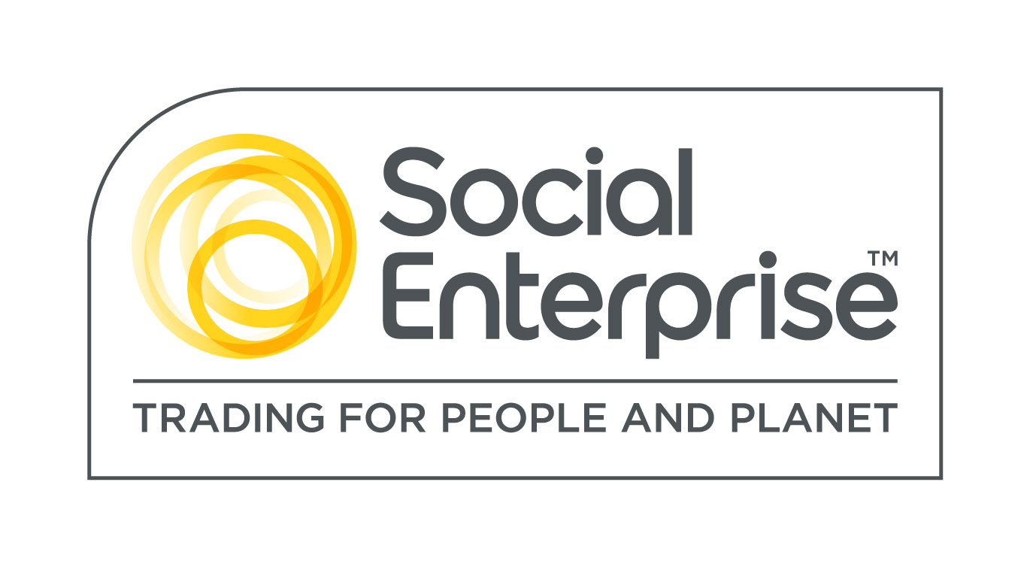
Watershed is a Social Enterprise Mark holder. Social Enterprises are businesses whose products and services create both social and environmental benefits.

