"Watershed is a place like no other - I feel free to be my whole self at work. Every day I feel professionally supported, challenged and free to contribute to the culture of the organisation” Zahra Ash-Harper, Pervasive Media Studio Producer.

Position: Rife Mentor
Grade:
Responsible to: Engagement Producer
Contract: Until December 31st 2020 / 20 hours per week
Purpose of the Job:

You will provide support and guidance to the Trainee Rife Content Creators involved in the Creative Workforce for the Future Programme Talent Network. Working with them in small groups and one-to-one to identify skills, overcome challenges and reach their goals.

Rife is an online magazine that supports young people to have their voices heard, develop skills in content creation and progress into the creative industries. We are currently advertising for new trainees – you can read more about the roles here.

Through Creative Workforce for the Future, Rife Magazine (Watershed) is working with The Guild (Coworking Bath), Knowle West Media Centre, Spike Island, CYN The Station, Bristol City Council and UWE Bristol to support creatives and businesses across the West of England to develop both industry employment practices embracing inclusion and diversity as an asset, and nurture young talent from certain under-represented groups to gain the experience required to sustain a creative career.

You will collaborate with mentors based at the five other cultural hubs (Knowle West Media Centre, Creative Youth Network, The Guild Co Working Space, Spike Island and Bristol Museums) involved in the programme to share best practice and design delivery of the programme.

You will also work alongside a Senior Relationships and Inclusion Manager based at the University West England who will support the creatives and businesses to participate in a Continued Professional Development focused on inclusion and employ the creatives. Some of these companies will host the Trainee Rife Content Creators for their industry placements. Read more about this here.

Duties and Responsibilities:

- Identify and set goals with mentees
- Agree a structured schedule of meeting that suits mentees
- Build trusting relationships
- Agree action plans and review progress
- Identify mentees skills and explore how to package and present them to employees/clients
- Liaise with the Rife Editors (line managers of Trainee Content Creators at Watershed) and Senior Relationship and Inclusion Manager’ to support the Trainee Content Creators to achieve their goals
- Liaise with mentors in other cultural hubs to share best practice and learning
- Make visits to mentees on placements
- Support mentees to develop strategies for dealing with challenges
- Support transitions from Rife to Industry and preparing for transition from the programme into Employment or Freelancing
- Increase self-confidence and self-esteem of mentees
- Working with the other cultural hub mentors contribute to the design and running of the programme and deliver sessions related to mentoring for the wider network of Rife Talent
- Monitor monthly training contract payments to Rife Content Creators, liaising with Finance Department and HR where applicable.

Key Performance Indicators
- Mentee action plans developed, and progress reviewed against goals
- Mentees feel supported and confident
- Positive working relationships with Rife Editors, Senior Relationship and Inclusion Manager and Programme Producer
- Positive contributions made to Talent Network design and delivery
- Mentee payments are monitored

Person Specification

Experience and Skills:
- Experience as a mentor in a similar setting
- Active listener and good communicator
- Open and honest
- Flexible and non-judgemental
- Ability to relate to young people and be a role model
- Understanding of the creative sector
- Understanding of inclusion practices
- Coaching qualification (desirable not essential)

Watershed Values
The Watershed brand is unique, trusted and respected and is driven by the following shared values which are clearly articulated. Ability to master and represent Watershed’s Vision and Values is therefore important.

Watershed is:
Inclusive | We are people led. We listen to and engage with the broadest range of people.
Open and Honest | We provide a culture and environment that is trusting, trusted and trustworthy.
Make Things Happen | We approach opportunity and challenge creatively, collaboratively and with a can do attitude.
Entrepreneurial | We are inventive, try new ideas, experiment, learn and share.
Celebratory | We celebrate culture, creativity and wonder.

Additional information:

- The successful applicant will be required to undertake an enhanced Disclosure and Barring Service (DBS) check, previously known as a CRB check.

- The post-holder is expected to wear clothing appropriate to their post.

- The post-holder will be required to undertake such other comparable duties as may be required by the Head of Department.

- Watershed is open seven days a week, including Bank Holidays (Christmas Day and Boxing Day are the only exceptions). Watershed is a public building, which operates a diverse range of cultural and commercial activities. The post holder will need to be comfortable working in this environment.
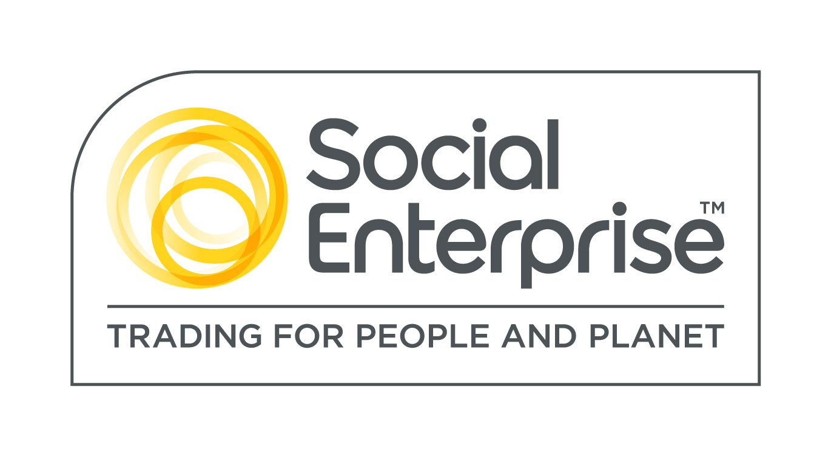
Watershed is a Social Enterprise Mark holder. Social Enterprises are businesses whose products and services create both social and environmental benefits.

Creative Workforce for the Future is funded by the West of England Combined Authority (WECA) and the European Social Fund (ESF).

