

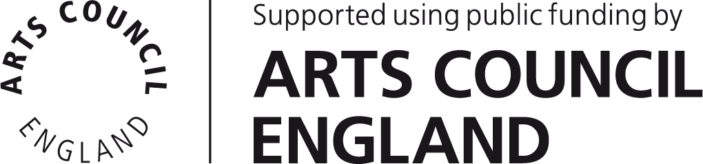

Studio Residencies 2014 Application

Name

Address

Contact number

Email

Website (if applicable)

Biog: Please provide a short biography outlining your background, interests and practice. (no more than 100 words)

Project overview: This should be a clear, compelling and concise summary of your project aimed at a general audience. This paragraph may be used for PR purposes should your application be successful. (no more than 100 words)

Please tell us why you’re applying: Why is this residency relevant to you and your practice? What difference will this opportunity make? (no more than 150 words)

Research Aims: What are your aims? What concepts and contexts will you explore? What do you hope to achieve? (no more than 300 words)

Technology: Please describe how your proposed project utilises new technology?
(no more than 200 words)

Approach: Please outline how you will approach this project. (no more than 200 words)

Outcomes & Legacy: What outcomes do you anticipate? How will this opportunity inform, shape or re-direct your practice beyond the timescale of the residency? (no more than 200 words)

Please provide examples of your arts practice by supplying web links and/or digital files of recent works, (we would recommend using a web service such as www.wetransfer.com for large files).

Links:

Please list any digital files provided:

Please return completed applications via email to:

Victoria Tillotson

victoria@watershed.co.uk

Deadline for applications: 9am, 16th June 2014

